International Information Technology University JSC

Faculty of Information Technology

Department of Information Systems

**Final project**

**«Software requirements specification development»**

**for discipline «Fundamentals of information systems»**

**Rakhmanov Nauryz and Umurzakov Ayan**

**______________________________________________________**

**(Authors)**

**“Get Chance UNT (Get Chance Unified National Testing)”**

**______________________________________________________________**

**(TOPIC)**

**Almaty, 2022**

**Final Project**

**«Software requirements specification development» For discipline «Fundamentals of information systems»**

**Aim of work** - development of full software requirement specification for development of information system.

**Symbols and abbreviations**

SRS - Software requirements specification

PP - Program product

UML - Unified Modeling Language

OS - Operating system

PC - Personal Computer

1. **INTRODUCTION**

Get Chance UNT is a platform that allows you to determine your chances of getting a grant at the university. Our platform provides applicants with the opportunity to find out in advance which university they can enroll in. To do this, you need to know your profile subjects and your overall score. Of which 2 subjects are specialized, for which there is a choice of specialties and university. Our platform takes into account your choice of subjects and, based on data from the past year, evaluates your results upon admission.

It should be borne in mind that the system does not guarantee 100% results, since the applicants' scores are growing every year. Accordingly, the competition for admission to the university is growing. But, on the other hand, our system can vouch for the reliability of the data provided and, in this regard, provides a very accurate list of universities to which an applicant can enroll.

We also thought through the idea of applicants who scored low scores. Candidates who will be registered in our service are given a chance to receive a grant. However, the draw will not be held among all users of the platform, but only among those who have a small chance to enroll in training without a contract. Among them, we will raffle a grant for any university of Kazakhstan in their main subjects. All this is done in order to support the younger generation and allow them to try their luck.

Our platform serves as a kind of guide for the future plans of the applicant, having received information about his chances, he can get acquainted with these educational institutions in more detail.

**2. GENERAL INFORMATION**

* 1. **Full name of IS and its abbreviation**

Get Сhance UNT (Get Chance Unified National Testing)

* 1. **Information about developers and customers**

**Developers:**

Name: Ayan Umurzakov

Contact number: + 77029566050

Address: Pushkin Avenue 67

E-mail: ayan.umurzakov@gmail.com

Name: Nauryz Rakhmanov

Contact number: +7 778 351 02 21

Address: Pushkin Avenue 67

E-mail: nauryz2003@mail.ru

**Customer:**

Business customer: Valve Corporation

Founder: Gabe Newell

Address: United States, 10900 NE 4th St., Suite 500 Bellevue, WA 98004, USA.

Email: email@support.steampowered.com

* 1. **Project timelines**

Work start date: 24/01/2022

Completion date: 05/05/2022

* 1. **Funding**

The work is financed from the funds of the Valve Corporation. The procedure for financing work is determined by the terms of Contract No. 1 dated February 9, 2022

* 1. **Purpose**

Our goal is to give the nearest reference point to the applicant at the choice of his university. After all, it all depends on which subjects the applicant chose and how many points he received on them. In this regard, we aim to facilitate the search for a university in their specialty. Our platform will store all possible combinations of specialized subjects with universities in this specialty.

* 1. **Scope**

Our project is relevant only for Kazakhstani applicants. Namely, those applicants who have passed the UNT exam and are interested in choosing a university. Since our project is relevant throughout Kazakhstan, we affect all cities and universities of Kazakhstan.

* 1. **References**

<https://www.symbolab.com/> - the most convenient and accurate calculator for calculations

<http://testent.ru/publ/> - a site where the average score for winning a grant will change every year

* 1. **Overview**

In our country, there are services that calculate the chances of admission in UNT subjects. There are also various services for preparing for the UNT, where you can also find out the passing points for the grant. However, in our project we have put all this together and are going to make not only the UNT calculator. We are also going to add the user to the database and identify him to some category of applicants. In this regard, we can understand whether he has enough points for admission. If suddenly it is not enough, then we have a favorable offer for all registered users - we are raffling off a grant to any university in your profile subjects.

**3 PURPOSES OF CREATING INFORMATION SYSTEM**

**3.1 Relevance**

The relevance of our project lies in the problem of choosing a university. In order to help the applicant after receiving the results of the UNT. We offer the applicant the opportunity to find out which universities in Kazakhstan are suitable for his scores. In other words, we select. Our project gives some guidance to applicants for their near future. This topic touches on the problems when an applicant does not know where to enroll and what opportunities open to him. For them, it can be a big step into adulthood, such as moving to a new city for new opportunities. This project will be very useful in society among teenagers who were thinking about going to university.

**3.2 Use**

* Finding a top-notch university
* Calculating chances of getting in/winning a grant

**3.3 Ideology**

The ideology of "Get Chance UNT" is to create a platform that can help and set guidelines about its future. The main task of the system is to help you see your capabilities and make your choice more clearly.

**3.4 Formulation of the problem**

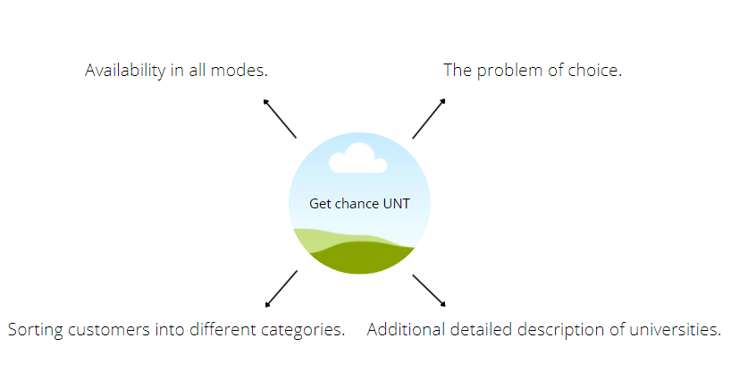

**3.5 Formalization of the problem**

Problem of choice

Due to the lack of skills, in most cases we are faced with the wrong choice of the right university. To solve this problem, we will create a separate guide page with recommendations for prospective students.

Sorting customers into different categories.

Our application will have all the available universities that young citizens of the country can enroll in.

Additional detailed description of universities.

Nowadays it is difficult to find plausible information, and even more so for schoolchildren who are just taking steps into adulthood. On our platform there will be a description of each university and what pros and cons it has. This will help in choosing a future university for admission.

**3.6 The goal**

**“Get Сhance UNT (Get Chance Unified National Testing)”**

The goal is to make it easier for prospective students to choose a university by identifying chances of admission

**3.7 Objectives**

* Analysis of problem solving to create the system “Get Chance UNT”
* Development of model programs included with new technology
* Development of algorithm by programming, databases, adding and combining in a single unit
* Development IS “Get Chance UNT” with February 2022 to May 2022
* Testing of IS in May 2022
* Debugging IS after testing

**3.8 Advantages**

• Dot percentage up to 95 state grant winnings

• Supportability of the application on any operating systems

• Necessary recommendations

• Convenient web design

**3.9 Disadvantages**

• There is a chance of a couple percent error

• No direct connection/chat with other people to communicate

**4 SOFTWARE REQUIREMENTS**

**4.1 Requirements for the structure and functioning of the IS**

**4.1. 1 Software technology used**

Database: MySQL

Frontend: HTML/CSS/JS

Backend: PHP

Software: XAMPP Server

Draw IO: Diagrams.net

**4.1.2 IS model**

Conceptual model IS

**4.1.2.1 Model selection**

On our site there is not only a description and percentage calculations, but you can also win a small discount on tuition if you study well and have good indicators. When using this app, customers first register with their phone numbers or email. They will have their own usernames and passwords. After that, good calculators with a database of universities are at your service. The site will be popular with graduating clients.

**4.1.2.2 Rationale for the chosen model**

We chose the conceptual model among all models because it characterizes the semantic structure, it is easy to obtain, and it is convenient to work with it.

**4.1.2.3 Construction of the general model**

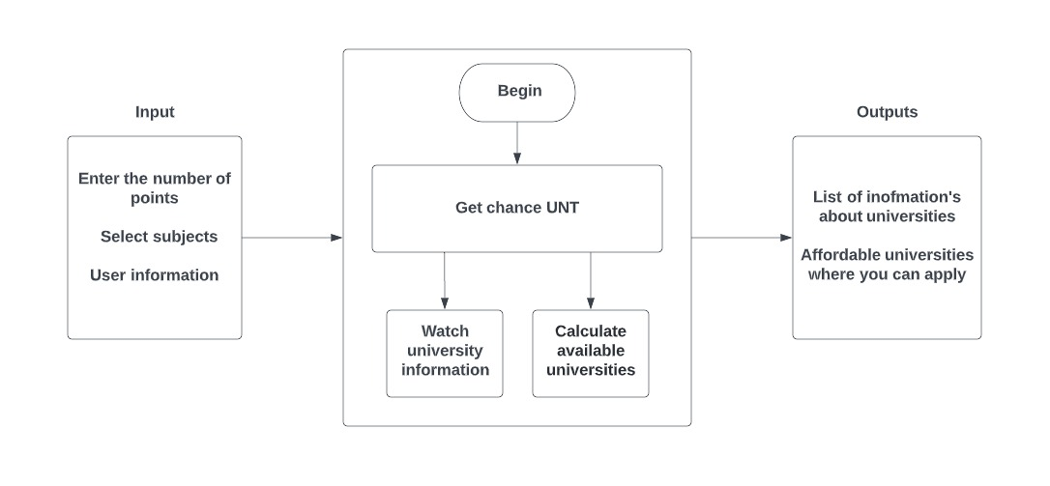

**4.1.3 IS Architecture**

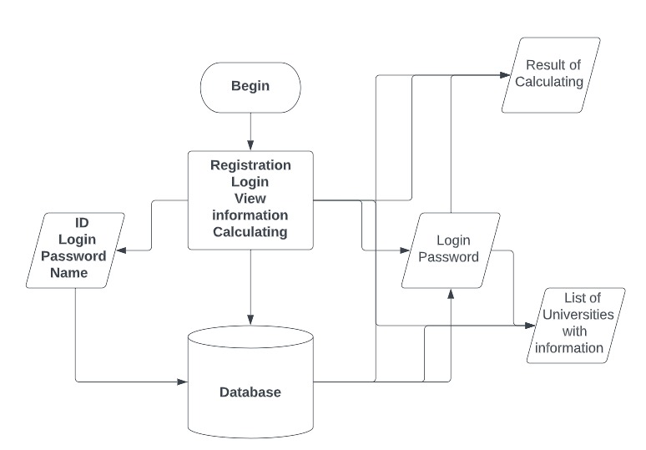

**4.1.4 Information support requirements**

The volume of multimedia information will be about 5-10 MB

**4.1.5 Software requirements**

Up to 2MB of memory per page

**4.1.6 Requirements to the construction of the algorithm**

**4.1.6.1 Structure of databases**

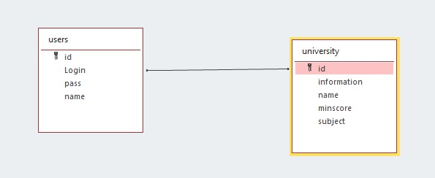



**4.1.6.2 Data Access Technology**

ADO- ActiveX Data Object (ActiveX-objects for data access)

**4.1.6.3 Requirements to the user data queries from the database**

- List of universities

- List of the users

- Authorization

- Request to verify the user in the database

- Request for points to calculate the probability of entry

**4.1.6.4 Requirements to the source code/programming languages**

- HTML/CSS/JS

- PHP

**4.1.6. 5 Modern theories and methods of IS development**

* Databases and knowledge bases

**4.1.7 OS requirements**

Windows 7+

Linux

macOS

Android

iOS

**4.1.8. Construction of the algorithm**

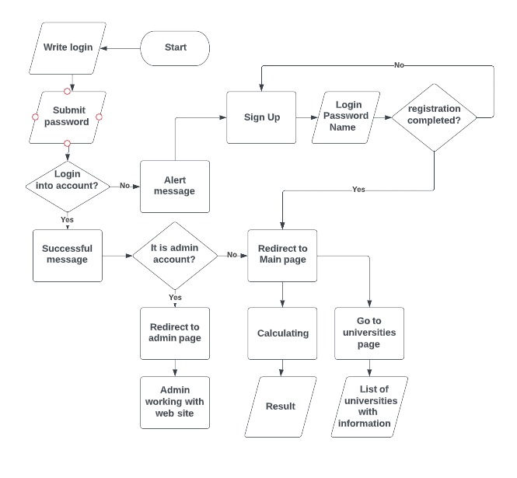

**4.2. Reliability requirements:**

One of the features of the service is its technical component. It consists in the fact that you can test and track all possible errors in a short period of time. Accordingly, you can adapt the service to the requirements of users.

**4.2 Requirements to reliability:**

Of course, for some reason, the service may hang, but it won't take much time. There are no actions in our service where the user can create an error and the content will not load. Since we have mandatory fields to fill in the content, without this the user will not know the result. Approximate time to correct possible errors: 5 minutes.

**4.3. IS Security**

**4.3.1. Copyright protection**

Author: Ayan Umurzakov

Email: [ayan.umurzakov@gmail.com](mailto:ayan.umurzakov@gmail.com)

Author: Nauryz Rakhmanov

Email: [nauryz2003@mail.ru](mailto:nauryz2003@mail.ru)

**4.3.2. Protection of information**

**4.3.2.1. Methods of protection**

**4.3.2.2. Protection algorithm**

The Advanced Encryption Standard (AES) The Advanced Encryption Standard (AES) is a specification for the encryption of electronic data established by the U. S. The design and strength of all key lengths of the AES algorithm (i.e., 128, 192 and 256) are sufficient to protect classified information up to the SECRET level. TOP SECRET information will require use of either the 192 or 256 key lengths. The implementation of AES in products intended to protect national security systems and/or information must be reviewed and certified by NSA prior to their acquisition and use.

**4.3.2.4. Protection against attacks**

- SSL certificate;

- Reliable hosting;

- Keep software up to date;

- Watch out for SQL injection;

- Check your passwords;

- Avoid file uploads;

- Use HTTPS.

**4.4 Requirements for exploitation**

**4.4.1 Exploitation conditions**

**4.4.1.1 Climatic conditions of exploitation**

This service works regardless of this

**4.4.1.2 Requirements to employees qualification and number**

**4.4.2 Help manual development**

**4.5 Technical requirements:**

**4.5.1 The recommended monitor resolution range at which software will be viewed is**

1920x1080px

**4.5.2 The minimal monitor resolution range at which software will be viewed**

Adaptive for all types of devices

**4.5.3 Recommended PC configuration**

**4.5.4 Minimal PC configuration**

There is no need to have a great PC configuration.

Any CPU

Any GPU

**4.6. Non-Technical requirements to IS:**

**4.6.1 Adaptability**

Our system will automatically adjust to any screen size. This will allow the user to use the web service regardless of the size of his device.

**4.6.2 Intellectual development**

Not required

**4.6.3 Consistency**

Not required

**4.6.4 Full functionality**

The application will be fully functional.

**4.6.5 Integrity**

Standard built-in plugins will be used. There is no need to use others.

**4.6.6 Quality**

This quality software, as the specification focuses on the characteristics that the user wants to receive

**4.6.6.1 Functionality**

The functionality of the service will be fully implemented and will continue to be subjected to various test tasks.

**4.6.6.2 Reliability**

The reliability of the service will be realized on the basis of a thorough check of the functionality and operation of the system. This can be achieved in the form of reducing errors and various bugs associated with data loss.

**4.6.6.3 Ease of application**

The ease of use of our website is based on the intuitive use of the service. That is, all the functions will be simple and clear to use.

**4.6.6.4 Effectivity**

The effectiveness of the site will be about 90%, technical failures are possible, but it will not take much time to fix them.

**4.6.6.5 Maintainability**

Design patterns will be used, so code changes will be quite simple, and, accordingly, if there are any site errors, you will be able to report.

**4.6.6.6 Possibility to learn**

Our website is simple and intuitive

**4.6.6.7 Modifiability**

Possibility to store data

Possibility of modification based on the received data

**4.6.6.8 Mobility**

This web service is available for use from any device.

**4.6.6.9 Finiteness**

Our website has technical support. If you notice any problems, you can write there.

**4.6.10 Accuracy**

Our service is based on providing accurate data as we calculate tasks based on mathematical operations. Accordingly, there should be no errors in the accuracy of the data.

**4.6.6.11 Autonomy**

All functions of our website work without any interruptions or errors.

**4.6.6.12 Stability**

Will maintain a given level of performance in case of failures and breaches of the rules of interaction with the environment.

**4.6.6.13 Security**

Оnly for the users will have access to the data. Each user will have its own identifier is.

**4.6.6.14 P-documentation**

The property is characterized by the presence, completeness, clarity, accessibility

and visibility of the training, guidance and reference documents necessary for the

application of the PC

**4.6.6.15 Informational content**

Web-service "Get Chance UNT" will contain all the features and user information.

**4.6.6.16 Sociability**

Simplified interface will be clear to all users.

**4.6.6.17 Time efficiency**

Service will always operational. Prolonged use of the service on the performance is not affected.

**4.6.6.18 The effectiveness of memory**

The most important functions are performed in priority order

**4.6.6.19 Efficiency devices**

Does not require a lot of memory, thereby simplifying the work.

**4.6.6.20 C-documentation**

In addition to the software, will be the presence of Documents, reflecting the requirements for the software and the results of various stages of development of the software, including capabilities, limitations, and other features of the software, as well as their justification.

**4.6.6.21 Intelligibility**

Simplified interface will be clear to all users.

**4.6.6.22 Structured**

When using design patterns, there can be no non-structured codes.

**4.6.6.23 Readability**

The web-service is easy to read and understand because of simple interface

**4.6.6.24 Extensibility**

It will have the ability to use more memory for data storage by using MySQL

**4.6.6.25 Modularity**

Every function of the operating system will interact with each other, but change the settings of properties that do not affect other properties.

**4.6.6.26 Regardless of the device**

All devices will be able to use our website.

**5 PSYCHOLOGICAL FEATURES**

**5.1.1 Aesthetic look**

The design of our website is in neutral colors

**5.1.2 Choice of style**

Since we have a minimal website design, it will be pleasant and convenient for users to use our services.

**5.1.3 Color solution**

Background colors: White, Deep Space Sparkle (#476269), Mauve (#C394F8)

Boxes color: #000000, #D3D3D3

Text color #FFFFFF (black), #000000(white)

**5.2 Location of interface elements**



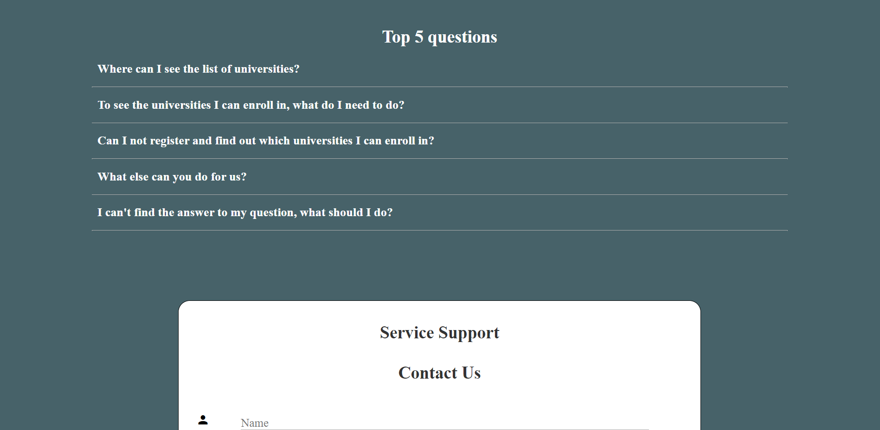

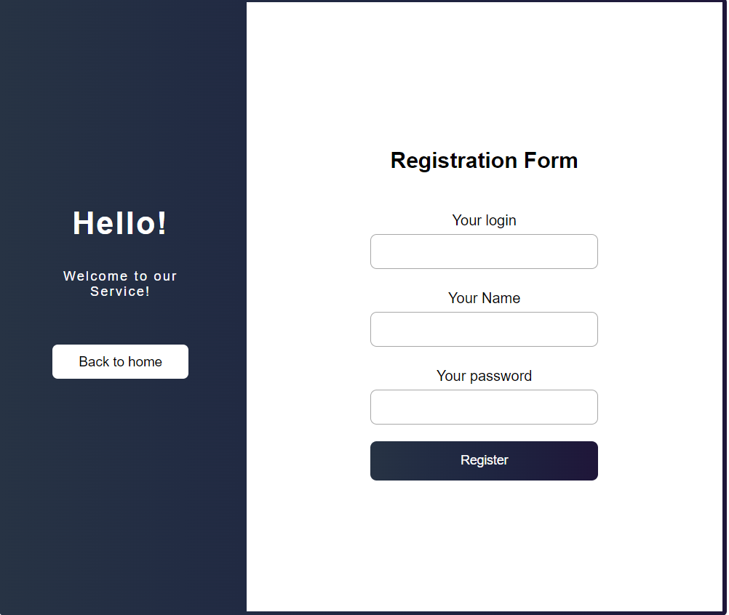



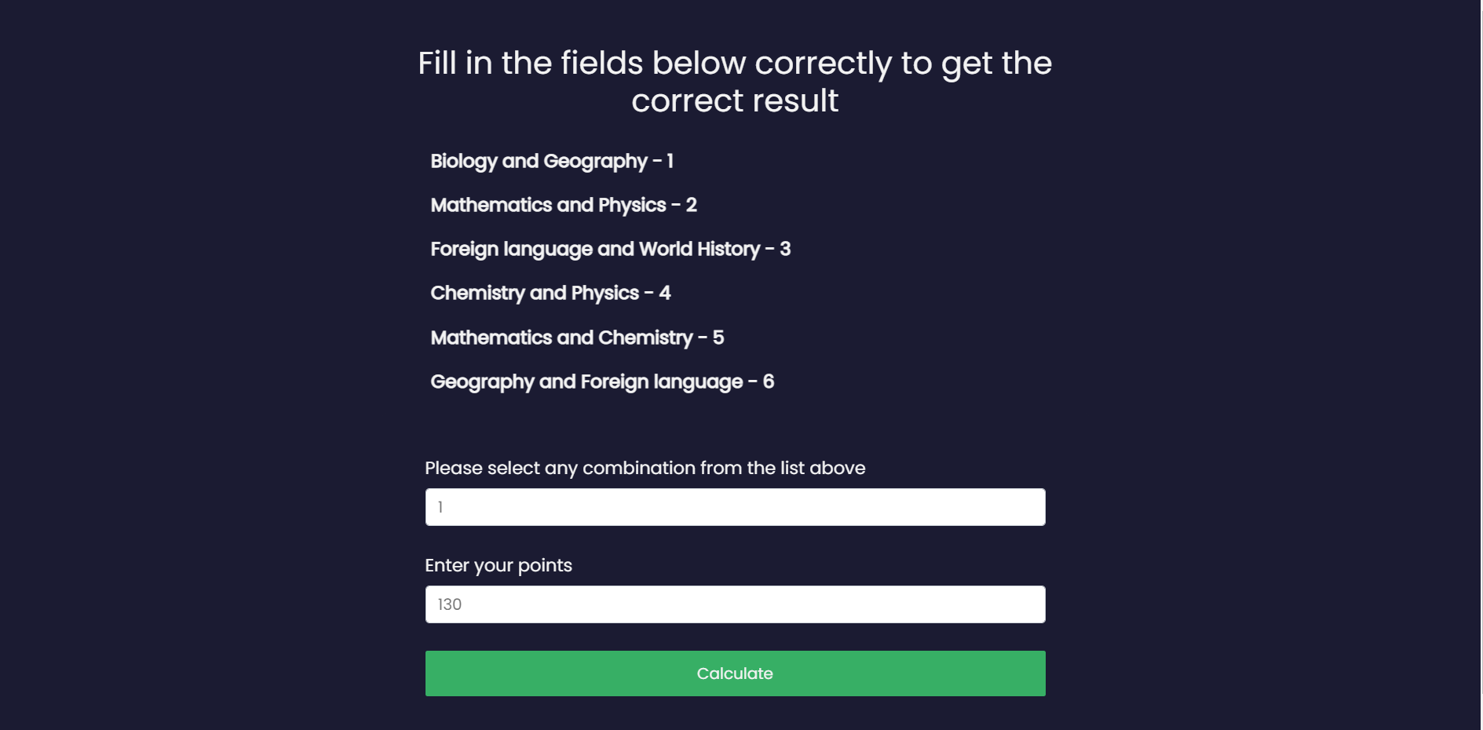

**5.4 Target audience**

**5.4.1 Age of users**

15+

**5.4.2 Their mood, temperament, etc.**

The most important factor is the desire of a person to enter a very good university, which can open many opportunities for a future student.

**6 ECONOMIC RATIONALE**

**6.1 Developing of IS business plan**

**6.2 Calculation of IS cost**

**6.2.1 Calculation of cost estimates**

**6.2.2 Calculation of IS development costs**

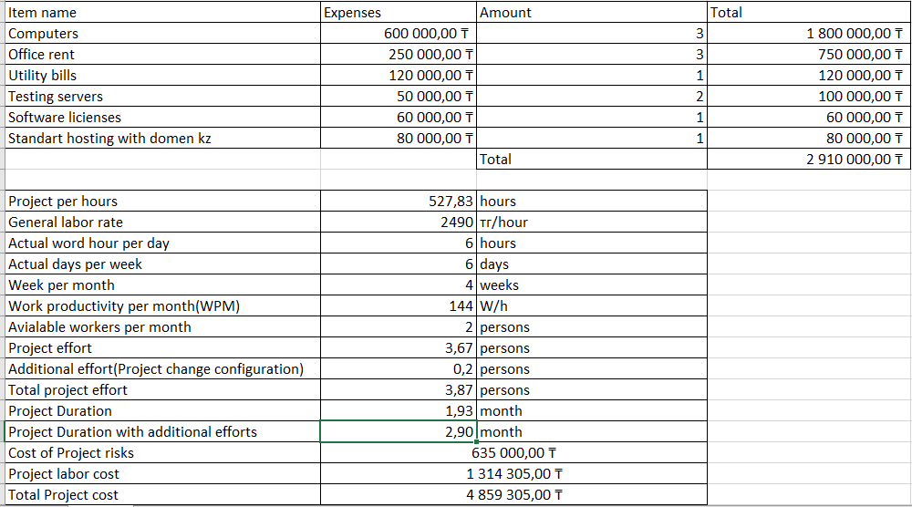



**6.2.3 Calculation of one CD (license) cost**

Our software will only have a website

**6.4 Building up its РR-campaign**

**6.4.1 Analysis of the market**

To analyze the market for software to determine the place of delivery of the developed program.

**6.4.2 Advertising campaign for the promotion of IS**

In the Internet, Instagram

1. **STAGES OF SOFTWARE DEVELOPMENT**
2. Writing technical specifications

A technical specification document outlines how you're going to address a technical problem by designing and building a solution for it.

1. Modeling

Modeling that allows us to demonstrate the desired structure and behavior software.

1. Analysis

Documented, comprehensive and systematic review of the project in order to assess its ability to meet quality requirements, identify problems and determine ways to solve them.

1. Development

The development stage is the part where developers actually write code, build the application according to the earlier design documents, and outlined specifications. Developers will follow any coding guidelines as defined by the organization and utilize different tools such as compilers, debuggers, and interpreters.

1. Testing

During the testing stage, developers will go over their software with a fine-tooth comb, noting any bugs or defects that need to be tracked, fixed, and later retested.

1. Debugging

It represents the process of finding bugs i.e. errors in software or applications and fixing them.

1. Support

Based on users’ feedback after using the product in a real environment, you are now able to improve your product with new features and eliminate any reccurring bugs and possible vulnerabilities

1. Promotion and sale

**8 IS TESTING AND DEBUGGING**

**8.1 Testing and Debugging IS**

Manual Testing

Errors:

* Spelling
* Stylistic
* Syntax
* Optimization

**Methods of debugging software IS**

**The method of manual testing.** This - the simplest and most natural way to this group. When an error is detected it is necessary to perform the program being tested manually using the test kit, at work with which the error was detected. The method is very effective, but not suitable for large programs, programs with complex calculations and in cases where the error due to wrong assumptions about the programmer some operations. This method is often used as part of other debugging techniques.

**8.3. Testing for malicious code**

Kaspersky Internet Security for Android is a FREE-to-download antivirus solution to help keep your phones and tablets - which can be even more vulnerable than computers - as well as your private information secure from online dangers.

**9 CONTROL AND ACCEPTANCE PROCEDURE**

**9.1 General requirements for IS acceptance**

**9.1.1 Deadlines**

5 may 2022

**9.1.2. Conditions of IS acceptance**

Software must fully comply with contractual technical specifications.

**9.2. Test report**

The test report shall include information about all the tests carried out on this software and their results.

Common errors

* Spelling
* Stylistic
* Syntax
* Optimization

**9.3. Acceptance Act**

**UML**

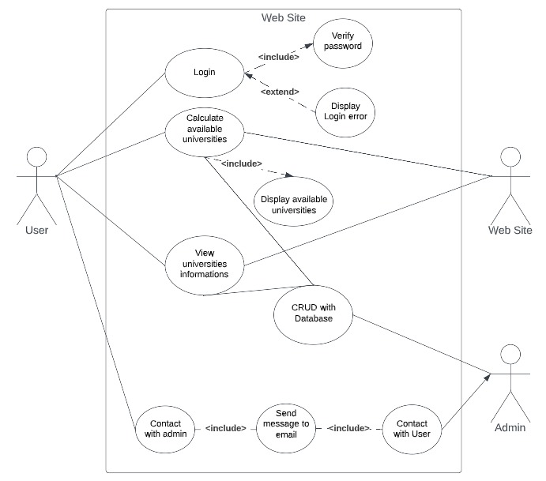

**Schema of the database**

